Paper Title Roughly 12-14 Words
(Font: Times New Roman 18 Bold)

First Author Zajtmann^{1*}, John Lau², and Anthony Kent³

¹ Full address of the first author, including affiliation and email
² Full address of the first author, including affiliation and email
³ Full address of the first author, including affiliation and email
*Corresponding and presenting author (use Times New Roman 10typerface for author’s Affiliation)

Abstract

The conference proceedings will be published in an electronic format. The entire paper file shall be written in compliance with these instructions. The author is asked to submit the paper in MS Word and Portable Document Format (PDF). Both files shall be saved with the full first author name as the file's name. An abstract not exceeding 300 words in English, after the authors' names and the corresponding author's contact information. The abstract is a concise recap of the problem addressed, the experimental design, results, discussion and conclusion of the work. Please indent the abstract first line 1.27cm.

Key Words: Minimum 3 and maximum 8 Key words.

(Double Spacing)

INTRODUCTION

Authors are required to submit full papers by 18 November 2025. Full papers should be submitted as a Microsoft Word file, 12 point, Times New Roman font, with page numbers at the bottom of the page and 1-inch (2.5 cm) margins, A4 size. Papers should be 3,000-5,000 words in length in English. Please provide a precise aim(s) and objective(s). Following the introduction, the main body of text should be organised into appropriate sections: literature review, methodology, findings and analysis, discussion, and conclusion. They are followed by acknowledgements (where applicable), references, and appendices (where applicable). Please indent the abstract first line 1.27cm. All the main body should follow 1.5 line spacing.

The second paragraph does not need the indent. The full paper must be submitted to Oxford Abstract

LITERATURE REVIEW
Double-line spaces between the end of the previous paragraph and section headings. Section Heads should be in Times New Roman, 12-point, bold and flush left in upper and lower case, as shown above. For subsection headings, only the first letter is capitalised. All the main body should follow 1.5 line spacing.

Subheading
The full paper must be submitted to Oxford Abstract

METHODOLOGY
Double-line spaces between the end of the previous paragraph and section headings. Section Heads should be in Times New Roman, 12-point, bold and flush left in upper and lower case, as shown above. For subsection headings, only the first letter is capitalised. All the main body should follow 1.5 line spacing.

Subheading
The full paper must be submitted to Oxford Abstract

RESULTS AND DISCUSSIONS
Double-line spaces between the end of the previous paragraph and section headings. Section Heads should be in Times New Roman, 12-point, bold and flush left in upper and lower case, as shown above. For subsection headings, only the first letter is capitalised. All the main body should follow 1.5 line spacing.

Subheading
The full paper must be submitted to Oxford Abstract

CONCLUSION
The Conclusions section must state expressly the extent to which the stated purposes of the article have been met or, if the study is ongoing, the potential implications (of the findings).

ACKNOWLEDGEMENTS
Please leave acknowledgements and references to funding sources until your paper has undergone the double-blind peer review and has been accepted for publication in the Conference proceedings. There will be an opportunity to complete this section before papers are finalised.

REFERENCES
The list of references must follow the Harvard referencing style in alphabetical order.

References must be in author alphabetical order following the Harvard referencing system. Referencing needs 1.0 line spacing. The style should follow these guidelines:
Last name, initials. (Year published). Title. City: Publisher, Page(s).
Last name, First initial. (Year published). Title. Edition. (Only include the edition if it is not the first edition) City published: Publisher, Page(s).
Last name, First initial. (Year published). Article title. Journal, Volume (Issue), Page(s).
Last name, First initial. (Year published). Article Title. Journal, [online] Volume (Issue), pages. Available at: URL [Accessed Day Month Year] (Accessed: Date Month Year).

The references (author, date, and page number) should be within the text. Please note quotations over three lines must be indented, ½ inch from the left margin, without quotation marks.

Example:
Kotler, P. and Armstrong, G. (2010) Principles of marketing. 9th Edn. London: Pearson Higher Education, pp.1-15.
O'Toole, G.A. and Kolter, R. (1998) ‘Flagellar and twitching motility are necessary for Pseudomonas aeruginosa biofilm development’, Molecular microbiology, 30(2), pp.295-304.

FIGURES
Place all figures centre page and number figures consequently. Figures must include a caption, be placed below figures, be centred, and have one line spacing between the main text, as shown below:
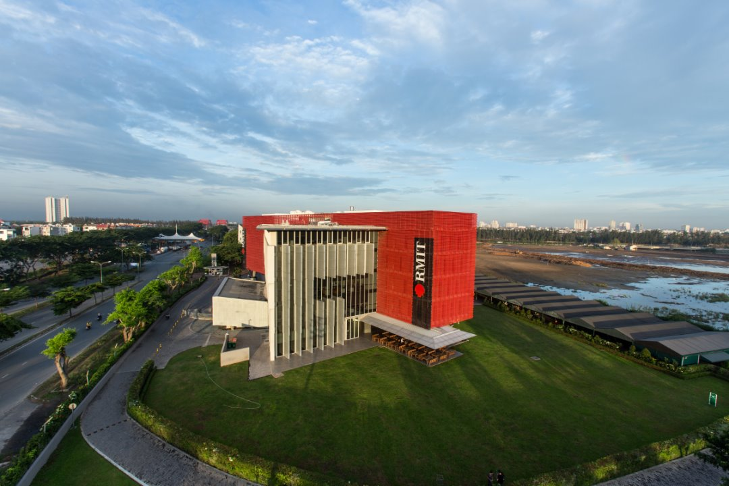

Fig. 1 RMIT Saigon South Campus, Ho Chi Minh City

When referring to a figure, use the figure number (Figure 1). Place figures close to the sections in which they are referred to.

TABLES
Number tables consecutively and use table numbers when referring to a table (Table 1). Place table centred page, with a caption above, as shown below:

Table 1. Title of table

 | 1 | 2
A
B
C
D

APPENDICES
In the conference proceedings, we are not recommending using appendices. However, you may think it is necessary to support your research. These are the guidelines of the conferencing proceeding Appendices. Please include related material that is not essential to present within the main body of the paper. Appendices should be structured A, B, C etc.

